

**CST120**

**Final**

**I have neither given nor received help on this exam: Chris Thomas**

**Test will not be accepted without signature.**

1. Using Labs 6 and 7, the lecture slides concerning the Analog to Digital Converter and Figures 1 and 2 below as guides answer the following:
2. You are using an Arduino UNO as shown in Figure 1 below with its 10 bit Analog to Digital Converter (ADC) and a 5 V voltage reference (Vref). You use the ADC to make a voltage measurement across the 10K thermistor and the ADC produces the number “614 (decimal)” to represent the analog input voltage. What is the value of the analog input voltage? Round the number to the nearest tenth of a volt (0.1V). (10 points)

614 * 5.0v = 3070 / 1024 = 3.0V

1. Using the chart and equation in Figure 2 – What is the temperature of the thermistor in

Part a above? (5 points)

-3.5549(3.0)^3 + 27.625(3.0)^2 – 89.697(3.0) + 132.3 = 15.8517

1. Use your knowledge of voltage dividers to determine if the resistance of the thermistor in this problem is lower than, equal to, or greater than the 10K. You do not need to give a numerical value as an answer. Just answer lower, equal or higher. (5 points)

higher

1. Which two bits in the ADCSRA register must be set to “1” to enable the ADC and start ADC conversion? (5 points)

Bit 7 enables the ADC and bit 6 starts the conversion.

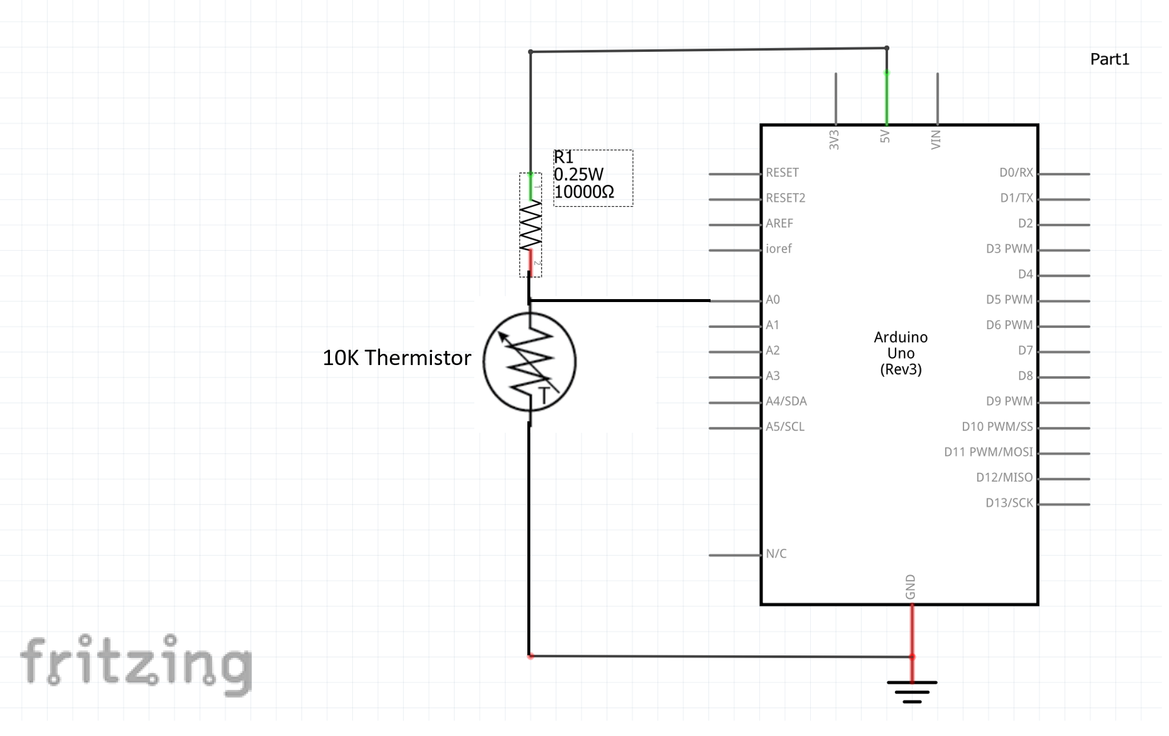

FIGURE 1

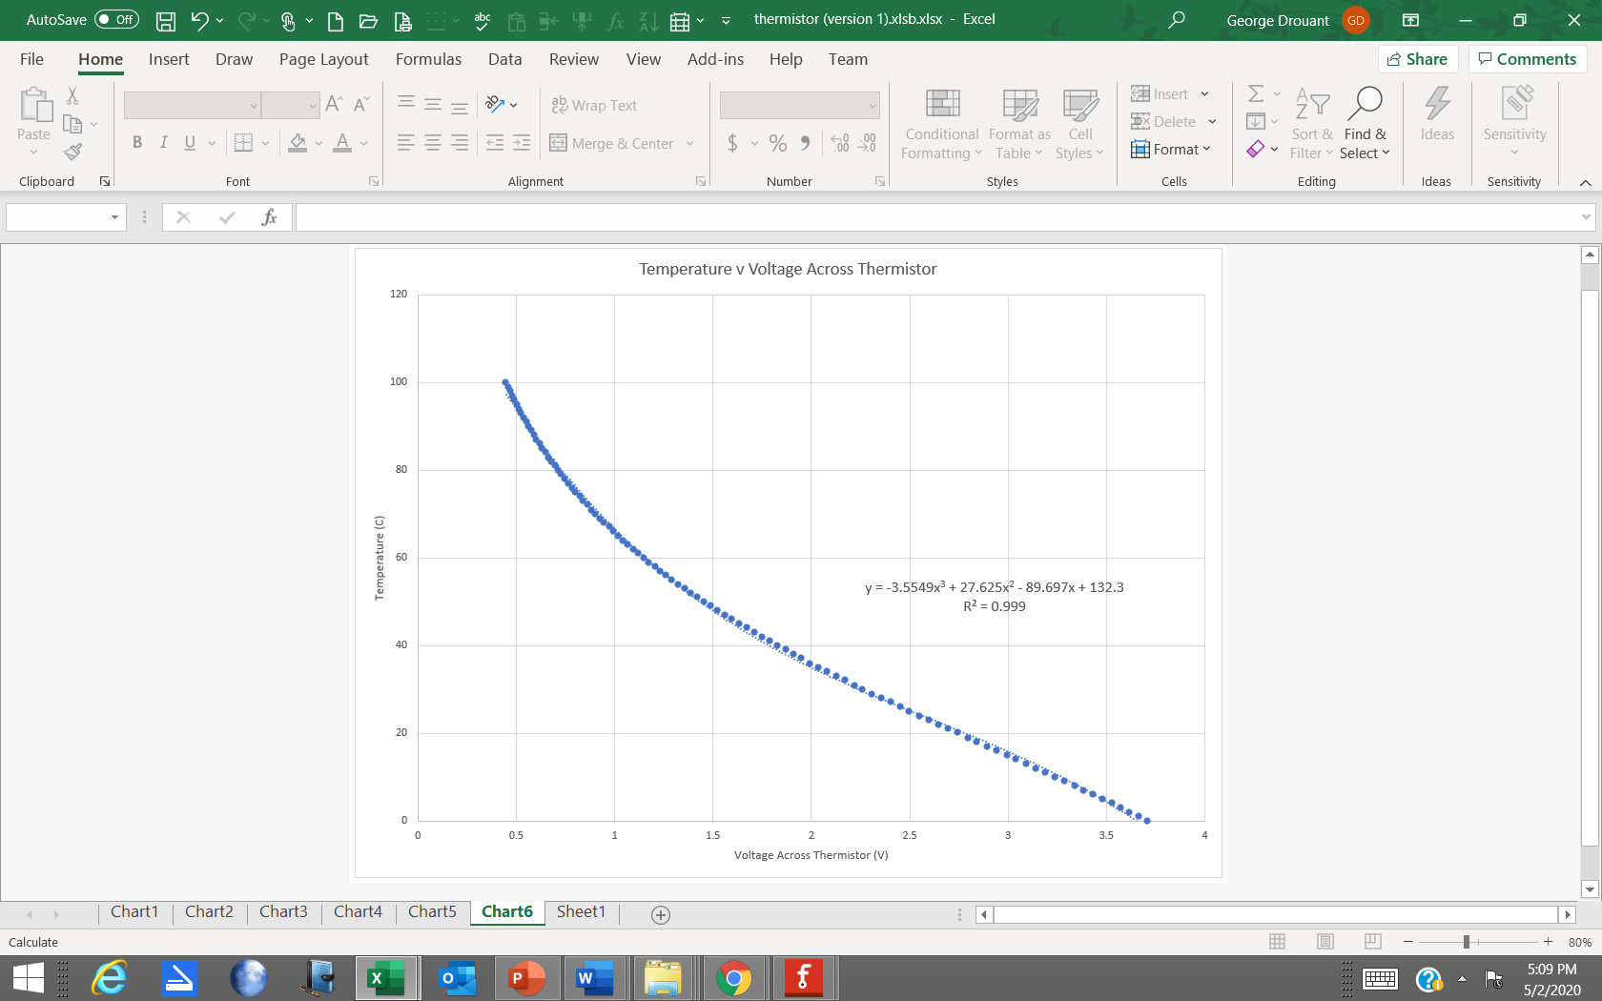

FIGURE 2

1. In this problem you will write a short program that will sound a buzzer for 1 second after a push button switch is pressed (press the button and buzzer buzzes for 1 second – see Figure 3). You will use external interrupt 0 (INT0) to cause an interrupt on a high to low voltage transition on the INT0 pin. The Interrupt Service Routine (ISR) will then cause the buzzer to buzz. Use your “active buzzer” – the buzzer that had the white label stuck to the top. Don’t worry about using a diode in parallel with the buzzer as we did in lab. I have discovered that it is not required with this buzzer. Recall that Lab 4 used interrupts and Lectures 8, 9, and 10 presented information about timers. Use PHOTO1 below as a guide to using the push button switch. Notice that the switch straddles the grove in the center of the protoboard. Also note that the wires are connected to the switch in a diagonal manner. PHOTO1 follows FIGURE3.

1. The switch is connected to the INT0 pin. To which pin is the switch connected (give Port and Pin number)? You may want to use the 328P’s datasheet to answer this question. (5 points)

Digital pin 2 on UNO -PD2

1. How do you turn on the internal pull up resistor associated with the INT0 pin? (5 points)

PORTD |= 0x04

1. The buzzer will be connected to Pin 4 of PORTB. Which Digital PIN on the Arduino board corresponds to Pin 4 of PORTB? (5 points)

Digital pin 12

1. Copy your main.c file and paste it into this Word document (this Final Exam). I will test it on my circuit to see if it works. (10 points)

/*

* final.c

*

* Created: 6/2/2022 7:45:50 AM

* Author : chris

*/

#define *F_CPU* 16000000UL

#define BUZZ (1 << DDB4)

#include <avr/io.h>

#include <util/delay.h>

#include <avr/interrupt.h>

int main(void){

PORTD |= 0x04; //activate pullup resistor on PD2

DDRB=0x10; //set DDRB4 to output

EIMSK |= (1<<INT0);//enable external interrupt 0 (digital pin 2 on UNO - PD2)

EICRA |= (1<<ISC01);//trigger interrupt on falling edge of signal into PD2

sei();//enable global interrupts

while (1)

{

}

}

ISR(INT0_vect)//interrupt service routine for external interrupt 0

{

PORTB ^= BUZZ;

*_delay_ms*(1000);

PORTB ^= BUZZ;

}

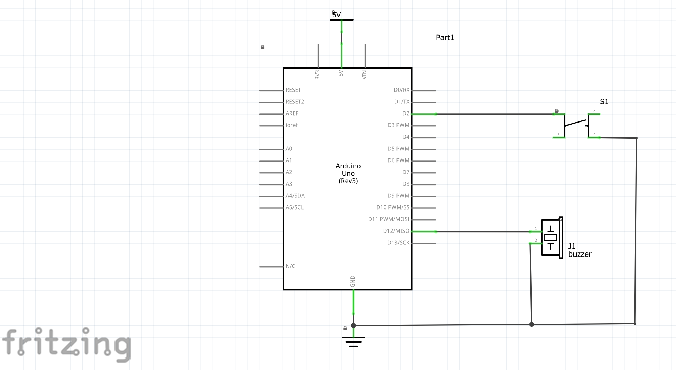

Figure 3

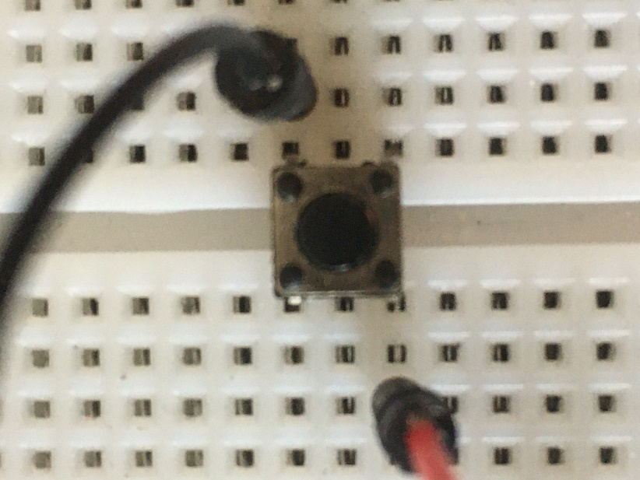

PHOTO 1

1. In this problem you will write a short program that continuously makes an LED turn on for one second and then turn off for one second. The LED will be connected to PORTB, Pin 4 as shown in FIGURE4 below. Notice that a 220 Ohm resistor is between the UNO port pin and the LED. It is there to limit the current from the UNO port pin. The value of that resistor can be from 220 Ohms up to 1000 Ohms. The LED will start blinking when the program starts and continue to blink until the program is turned off. Timer1 operating in mode 4 will be used to create the 1 second time interval. Mode 4 is also called CTC or Clear Timer on Compare match. In Mode 4 when the timer/counter reaches the count stored in OCR1A, the timer/counter is cleared to zero and again starts counting up to the count stored in OCR1A. A prescale value of 256 will be used. Remember that Lectures 8, 9, and 10 and Lab 4 presented information concerning the use of timers. Additional information on Timers can be found in the datasheet for the 328P.
2. What will be the values of the CS10, CS11, and CS12 bits in register TCCR1B? (5 points)

CS10 = 0 CS11 = 0 CS12 = 1

1. What will be the values of the WGM10, WGM11, WGM12 and WGM13 bits? (5 points)

Table 16-4 of the 328P datasheet can help with this question.

WGM10 = 0 WGM11 = 0 WGM12 = 1 WGM13 =0

1. What value will be placed in the OCR1A register? (5 points)

62500

1. Copy your main.c file and paste it into this Word document (this Final Exam). I will test it on my circuit to see if it works. (10 points)

/*

* final.c

*

* Created: 6/2/2022 7:45:50 AM

* Author : chris

*/

#define *F_CPU* 16000000UL

#define LIGHT (1 << DDB4)

#include <avr/io.h>

#include <util/delay.h>

#include <avr/interrupt.h>

int main(void){

DDRB=0x10; //set DDRB4 to output

// Setup Prescaler - divide 16MHz by 256

TCCR1B |= (1 << CS12) | (1<<WGM12);

// Setup Output Compare Register A

OCR1A = 62500;

while(1)

{

if(TIFR1&(1<<OCF1A))

{

// Reset counter

TIFR1 = (1<<OCF1A);

PORTB ^= LIGHT;

}

}

}

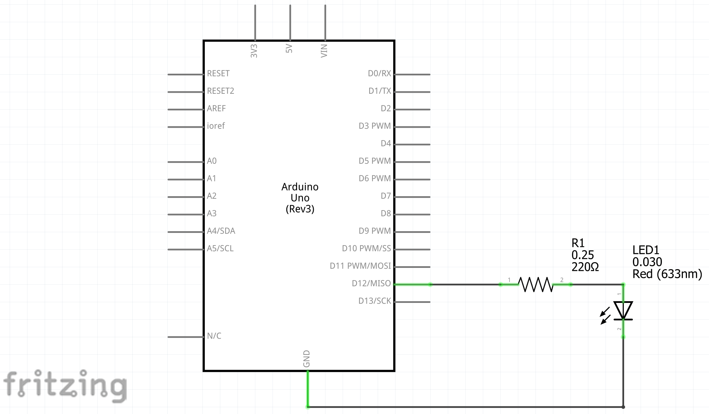

FIGURE 4

1. Figure 5 shows an oscilloscope trace of an ASCII character being sent from an UNO to a computer. The transmission rate of the UNO’s serial port was 9600 baud. Eight data bits were transmitted. No parity bit was transmitted, and one stop bit was transmitted. The start bit begins at 0.0 milliseconds and ends at 0.104 milliseconds (the horizontal axis of the trace is time in milliseconds). The stop bit starts at 0.9375 milliseconds (just before the blue trace ends). The vertical axis of the trace is the voltage. A high level - or logic one - has a voltage of 5V and a low level -or logic 0 - has a voltage of 0V. Remember that an introduction to serial communications was given in Lecture 19.
2. Which ASCII character was transmitted in FIGURE 5? What is the hexadecimal value of the ASCII character? FIGURE 6 is an ASCII Table. (10 points)
   1. 0110 0111 = 67
   2. g
3. Explain the difference between serial and parallel communication. (5 points)
   1. Parallel Data Transmission transmits more than one bit of data at a time
   2. Serial Data transmission transmits one data bit at a time
4. Explain the difference between synchronous and asynchronous communication. (5 points)
   1. Synchronous separate clock signal synchronizes data
   2. Asynchronous data patterns synchronize data (no clock)
5. Explain the difference between Half Duplex and Full Duplex communication. (5 points)
   1. Half duplex is one way communication where full duplex allows both sides to receive and transmit simultaneously.

**Bonus Question:** What does the C keyword “volatile” do? (3 points)

It tells the compiler to leave it alone and not take it out when doing an optimization run.

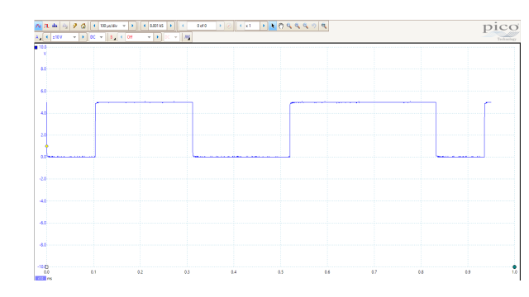

FIGURE 5

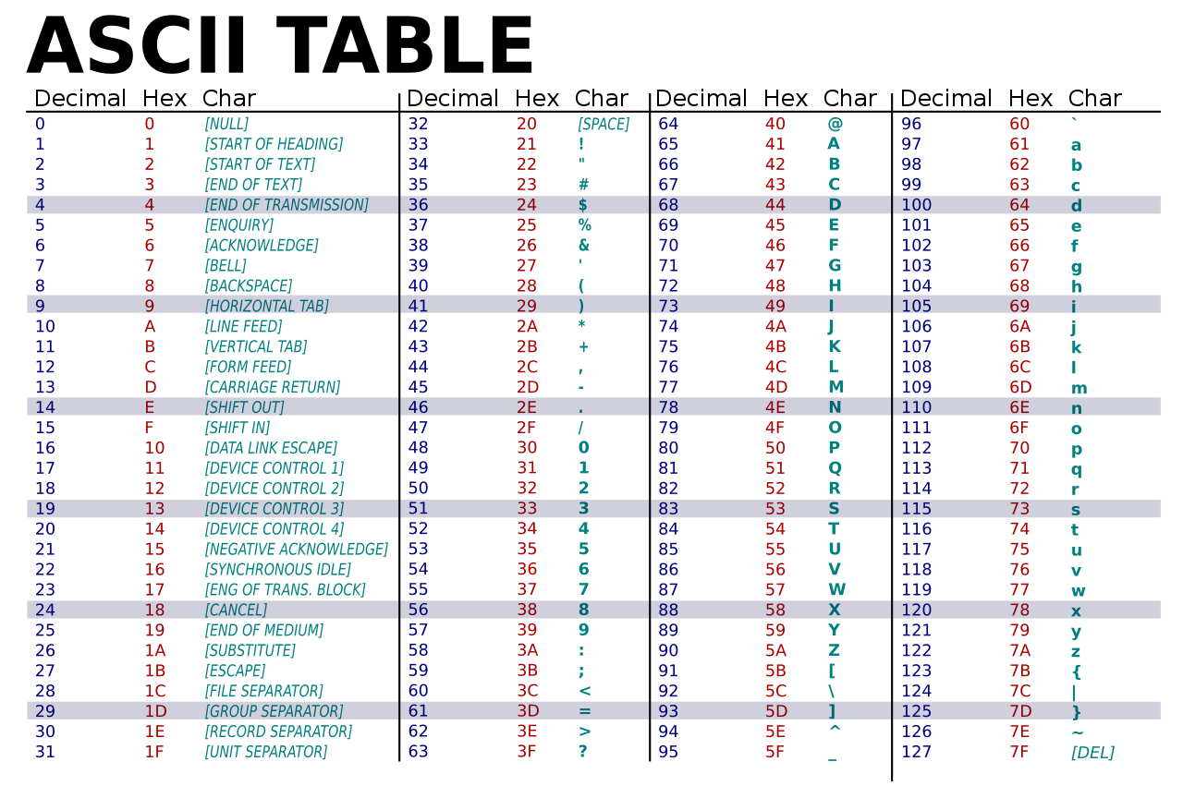

Figure 6